Project Roller Coaster

Summary: You and your team will work like professional engineers who work on expensive multi-million-dollar projects from the design to the final product. This is your team’s challenge:
- Design a simple roller coaster, that is one with two dimensions – only hills and valleys –but consider friction forces from the beginning of design process.
- Estimate the velocity of a rolling body along a curved path, considering friction forces.
- Use an excel spreadsheet to evaluate and graph functions (I have a spreadsheet prepared at my website.)
- Build a functional model from a mathematically generated design.
- Determine the reason why possible models might not behave as expected in the “on paper” design.
- Calculate the cost of your model.
- Develop a project proposal folder and “sell” your project to Mrs. Brown.

First Deadline: You cannot move to the construction phase until this is approved and turned in!
Design Draft
- The conditions for this project are: initial ball bearing’s velocity at the beginning of the path equals zero, final velocity at the end of the path also must be zero (or almost). Your design must be efficient enough that the initial potential energy of the body (ball bearing) is enough to make it complete through the entire path.
- Draft your design by hand the roller coaster path, while keeping the same designs: no loops and a simple Russian Mountain path composed of parabola-like curves.
- Determine the x-y coordinates of points on the path. You must have a point at the top of your parabola and at the bottom. There needs to be at least 4 points graphed between the top of the curve and the bottom. (See figure a)
- This must be a scaled blueprint. (Suggested 1-unit:1-inch scale)
- Enter the sketch coordinates into the spreadsheet found on my website. Print off your designed path and the calculated velocities. Make two copies. One will be placed on your display board and the other will in your project proposal. (See figure b)

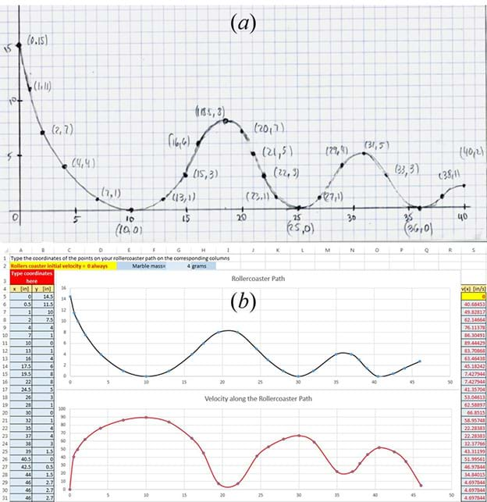

Second Deadline:
Model Construction
- Build a physical model using the foam pipe insulation. Your model must match your design dimensions.
- You must keep up with your “construction costs” on your cost and evaluation sheet. (Go to my website for this sheet. Type information directly into the sheet. Once completed make a copy and keep for later.)
- You will attach your roller coaster to a display board.
- Your coaster must be transportable. (I can move it out of my way if need be.)
- Test your model at least 10 times and record the results. Make conclusions about your design and model. Is the model behaving as expected? If not, why? What were the failures? How did you solve them?

Third deadline:
Project Proposal Folder
- Cover page with project name and team members names
- Page with project description and purpose, and a summary of the results obtained from model testing.
- Copy of the scaled blueprint
- Copy of excel spreadsheet data with the graph of your designed path and the calculated velocities.
- Page that describes the construction process, materials used, final dimensions, accuracy with respect to mathematical design, and photos of the constructed roller coaster model.
- Copy of the cost and evaluation sheet.
- Page with final conclusions about how similar the expected results were from the mathematical design, and the final prototype results.
*You need to put all the above in an unused folder that has brackets in it. We are trying to emulate professional engineers; therefore, the project folder needs to look professional. You are trying to sell your project to me and your classmates.
Project Presentation
Your team will present your project to the class. Everyone will have a speaking part in this presentation. You will present your proposal folder to me on this day. Make sure your prototype is in good working condition. Show the class a test of your coaster. Try to sell us your project idea. In other words, “Why should we buy your blueprints and not another group?”
Notes: • No projects accepted after the due date: • In-class project-presentation is mandatory. • During tutorial time (8th period), help will be available for the physics concepts, Excel calculations and graphs, physical model construction, and presentation. • Due date: [ __________________]

Grading
Because of the amount of time invested in this project, it will count as a test grade. It will be in four parts:
- Design phase (30 points)
- Model (30 points)
- Project Proposal Folder (25 points)
- Project Presentation (15 points)

